7 DECEMBER 2018 -SECOND PLACE NANDHA COLLEGE OF PHARMACY CULTURAL FEST

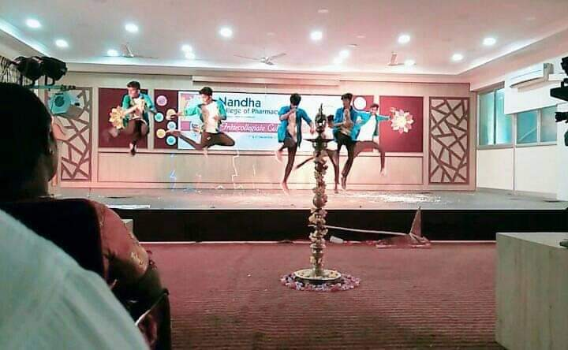

DECEMBER 2021 MR.RENAISSANCE -WINNER JKKM COLLEGE OF PHARMACY INTER COLLEGIATE FEST

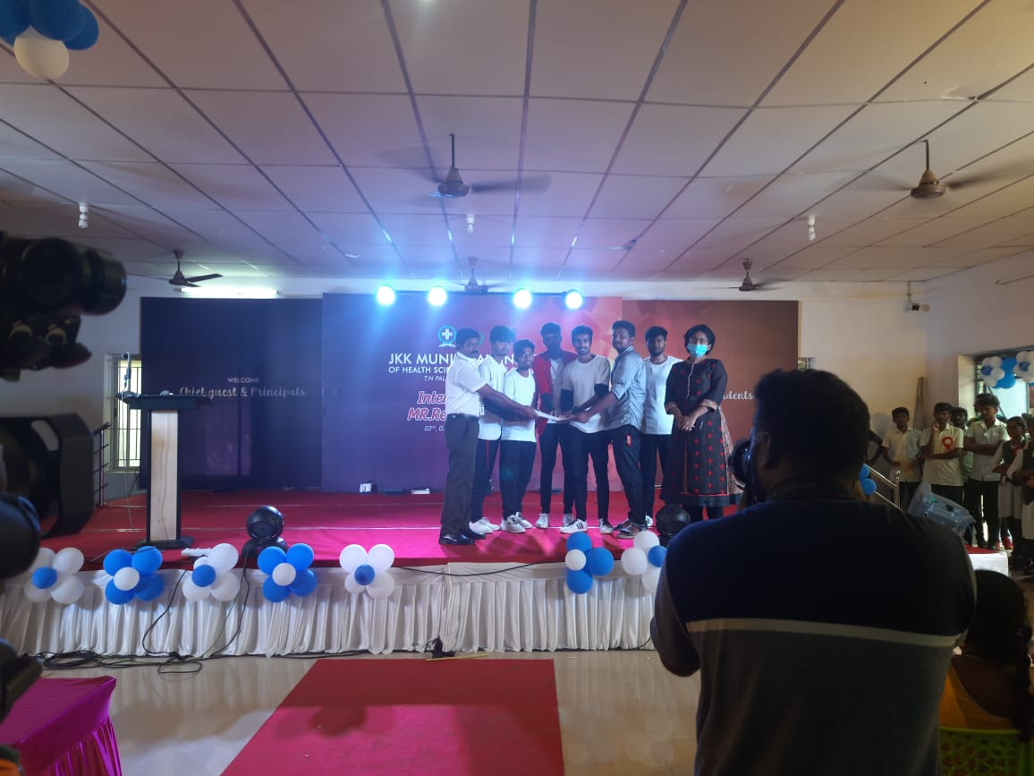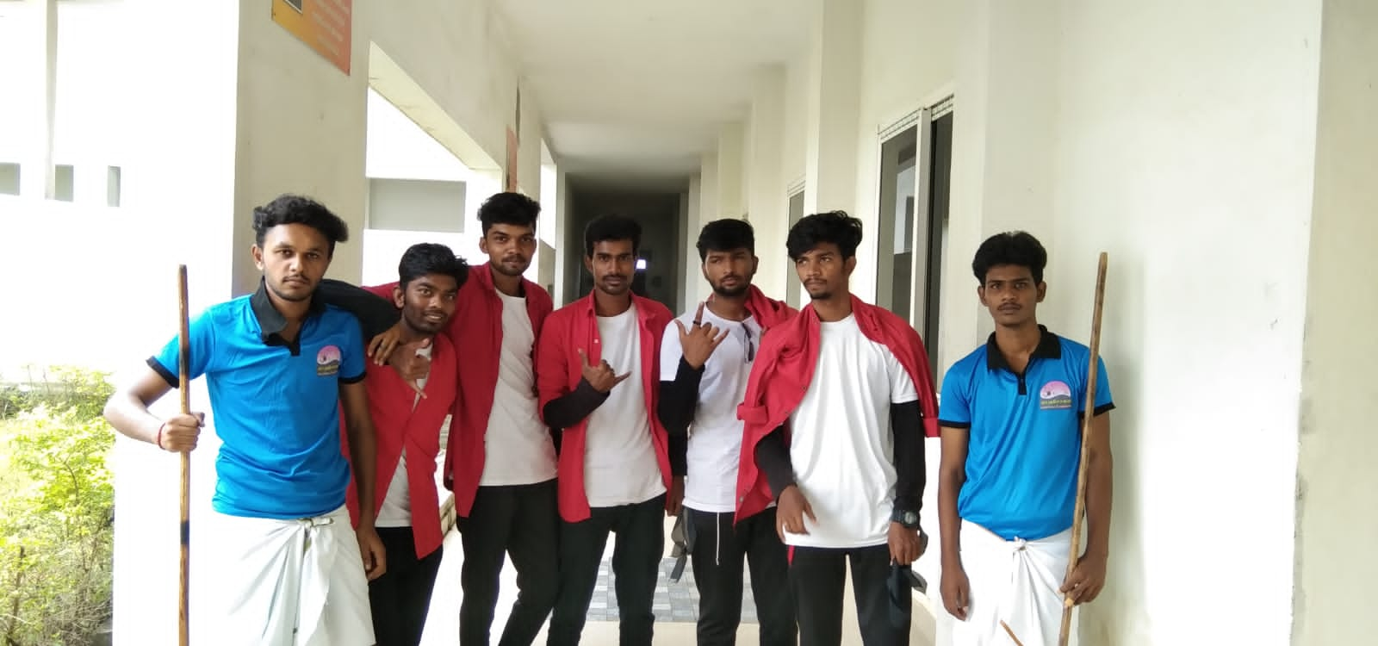

24 JUNE 2022- WINNER JKKN COLLEGE OF PHARMACY IN CULTURAL COMPETATION

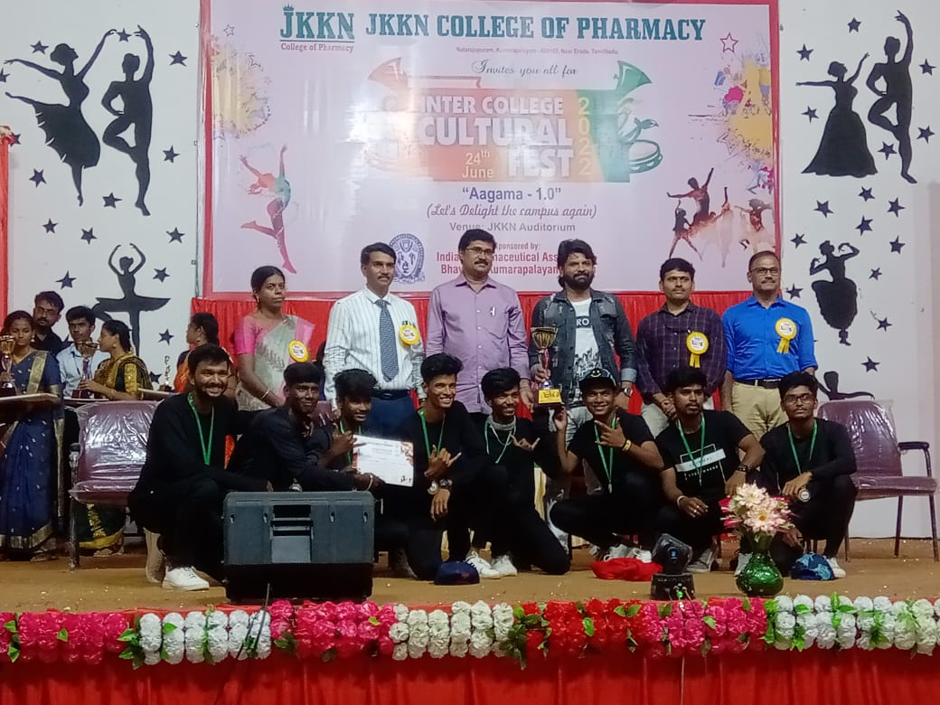

DANCE COMPETATION IN VIJAY TV

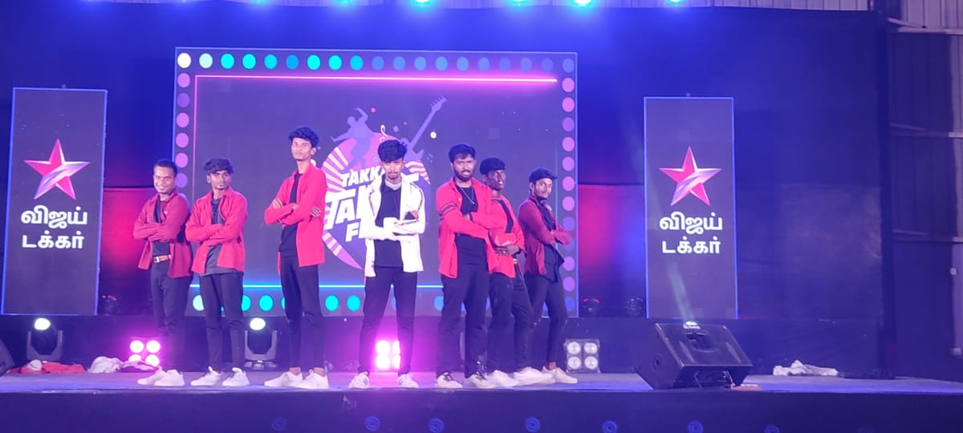

PHARMA AURA -2022 NOV-18 ND 19TH OF NOVEMBER (INTERCOLLEGE CULTURAL FEST)

